Criterion 1: Outcome-based Curriculum (120)

1.1. Vision, Mission and Program Educational Objectives (PEOs) (35)

1.1.1. State the Vision and Mission of the Institute and the Department (05)

Vision of the Institution | Promote academic excellence, research, innovation, and entrepreneurial skills to produce graduates with human values and leadership qualities to serve the nation.
Mission of the institute | Provide student-centric education and training on cutting-edge technologies to make the student’s globally competitive and socially responsible citizens and Create an environment to strengthen the research; innovation and entrepreneurship to solve societal problems.
Vision of the Department | Promote Innovation-centric education to produce globally competent graduates in Computer Science and Engineering education & research capable of building a strong and developed nation.
Mission of the Institution | M1 | Provide rigorous course work and State-of-the-Art laboratories for the students to make them globally competent
 | M2 | Strengthen the department interaction with Multi-National Companies to enhance graduate technological advancement skills and research capabilities
 | M3 | Impart human values and ethics to the graduates for serving the society with highest regard to the mother land

1.1.2. State PEOs of the Program (05)

The PEOs of the B. Tech Computer Science and Engineering Program are the broad statements that describe the career and professional accomplishments that the program is preparing graduates to achieve. PEOs are defined with input from all program constituents and describe the expected accomplishments of graduates during the graduation.

Program Educational Objectives (PEOs):
PEO No | Program Educational Objectives Statements
PEO1 | Graduates of the program will have a globally competent professional career in software Industry
PEO2 | Graduates of the program will pursue higher education and research
PEO3 | Graduates of the program will have entrepreneur skills to solve societal problems

1.1.3. Process of Defining Vision, Mission and PEOs (10)
Process Involved in Defining Vision and Mission
The vision and mission of the department are established after a thorough process and consultative approach involving all the stakeholders. The following steps are involved.
- The convener of the Program Assessment Committee (PAC) calls for PAC meeting to define vision and mission of the department based on Institute vision and mission for every three to five years or when vision and mission of the institute is redefined.
- In the first meeting the members identify stakeholders (External/Internal) and the formats through which their inputs are sought.
- The chairman of the Department Academic Committee (DAC) collects the input from the PAC and prepares reports within a week.
- The committee meets periodically to finalize vision and mission of the department and ensure that it is in Alignment with Institute vision and mission.
- The framed department vision and mission sent to Board of Studies (BOS).
- BOS meeting will be scheduled by its chairman to review the Department vision and mission sent by DAC such that BOS inputs/requirements are met.
- College Academic Council headed by Principal is scheduled to review/refine the Department vision and mission received from BOS.
- Once the vision and mission of the department is finalized by the committee, head of the department ensures its publication and dissemination.

- Description Process of defining vision of the department from the vision of the institute
The department established the vision and mission through a consultative process involving the stakeholders of the department.
To establish the vision and mission of the department, the following process is followed:
The Process:
- Periodic Review Meetings
- The department conducts a formal review meeting to evaluate and potentially redefine the Vision and Mission statements.
- This review is scheduled every three to five years, or earlier if the Institutes Vision and Mission undergo any modifications.
- The purpose is to ensure alignment with the institutions evolving goals, societal needs, and global trends in education and technology.
- Stakeholder Feedback Collection
- Feedback is collected from all relevant stakeholders including:
- Students
- Faculty Members
- Alumni
- Employers/Industry Experts
- Academic Experts
- Inputs are gathered through surveys, meetings, and consultations.
- A comprehensive report is prepared based on this feedback, highlighting suggestions, expectations, and alignment with educational objectives.
- Internal Committee Deliberations
A departmental committee comprising senior faculty and coordinators conducts multiple deliberation sessions.
- The goal is to revise or reaffirm the departments Vision and Mission based on:
- Stakeholder input
- Academic and industry trends
- Institutional goals
- Careful attention is paid to ensure that the departmental Vision and Mission remain aligned with the Institutes Vision and Mission.
- Approval Process
- The revised/finalized Vision and Mission statements are first endorsed by the Program Assessment Committee (PAC) and the Department Advisory Committee (DAC).
- Upon endorsement, the statements are submitted to the Board of Studies (BoS) for final approval and formal adoption.
- Board of Studies (BoS) Approval
- The finalized Vision and Mission statements are submitted to the BoS for official approval at the departmental level.
- College Academic Council (CAC) Approval
- After BoS approval, the statements are forwarded to the College Academic Council (CAC) for final institutional-level endorsement.
- This ensures that the Vision and Mission are institutionally validated and aligned with broader academic and strategic objectives.

      - PAC Committee members:
S.No. | Name & Detail of Member | Designation
1. | Dr. Ajmeera Kiran  Assoc Professor & HOD CSE, MLRIT | Chairman
2. | Dr. Allam Balaram  Professor in CSE, MLRIT | Member-Dept. of CSE
3. | Dr.K.Venkata Subbaiah  Professor in CSE, MLRIT | Member-Dept. of CSE
4 | Dr.K.Pushpa Rani  Assoc.Professor- CSE, MLRIT | Member-Dept. of CSE
5 | Mrs.D.Divya Priya  Assoc. Professor- CSE, MLRIT | Member-Dept. of CSE
6 | Mr.V.Sai Krishna  Assoc Professor CSE, MLRIT | Member-Dept. of CSE
7 | Mr.B.Murali Krishna  Assoc Professor, CSE, MLRIT | Member-Dept. of CSE

      - The Department Academic Committee Members
S.No. | Name & Detail of Member | Designation
1 | Dr. Ajmeera Kiran  Assoc Professor & HOD CSE, MLRIT | Chairman
2 | Dr. Allam Balaram  Professor, CSE,MLRIT | Member-Dept. of CSE
3 | Dr.K.Venkata Subbaiah  Professor, CSE,MLRIT | Member-Dept. of CSE
4 | Dr.K.Pushpa Rani  Assoc Professor CSE, MLRIT | Member-Dept. of CSE
5 | Dr.V.Thrimurthulu  Professor, CSE,MLRIT | Member-Dept. of CSE
6 | Mr.T.Nagarjuna  Assoc Professor CSE, MLRIT | Member-Dept. of CSE
7 | Dr.G.John Samuel Babu  Assoc Professor, CSE, MLRIT | Member-Dept. of CSE
8 | Dr.K.Gagan Kumar  Assoc Professor, CSE, MLRIT | Member-Dept. of CSE
9

      - The BoS Members
S. No | Name & Details of Members | Designation
1 | Dr. K Srinivas Rao  Professor & Principal, MLRIT | Chairman
2 | Dr. Ajmeera Kiran  Assoc Professor & HOD CSE, MLRIT | Member Secretary
3 | Dr. K Sai Prasad  Assoc Professor & HOD CSE- AI&ML, MLRIT | Member Secretary
4 | Dr. P Subhashini  Assoc Professor & HOD CSD, MLRIT | Member Secretary
5 | Dr. N.V. Raja Sekhar Reddy  Assoc Professor & HOD IT, MLRIT | Member Secretary
6 | Dr. Ch Asha Jyothi  Assoc Professor in IT, JNTUH UCEW | Member - JNTUH Nominee
7 | Dr. B Padmaja Rani  Professor of CSE, JNTUH CEH | External Academic Member
8 | Dr. K Supreethi  Professor & HOD of CSE, JNTUH CEH | External Academic Member
9 | Mr Nagarjuna Malladi  Delivery Head, Tech Mahindra | Industry Expert
10 | Mr. Aditya Sambamoorthy  Founder & CEO InLustro | Industry Expert
11 | Mr. Tharun Theja S  Associate Director - Blueverse (AI Services) LTIMindtree | Industry Expert
12 | Mr. Mupparapu Vamshi Krishna  Founder & CEO  EMELEX Business Solutions LLP | Industry Expert
13 | Mr. Anirudh Pucha  Lloyds Technology Centre  Senior Solution Architect | Industry Expert
14 | Mr. C Srikanth  Associate Engineer, DevOps  VIRTUSA Consulting Services Pvt Ltd | Alumni & Industry Expert
15 | Dr. K.Venkata Subbaiah  Professor, Department of CSE, MLRIT | Internal Academic Member
16 | Dr. K. Pushpa Rani  Assoc Professor, Department of CSE,MLRIT | Internal Academic Member
17 | B.Murali Krishna  Assoc Professor, Department of CSE,MLRIT | Internal Academic Member

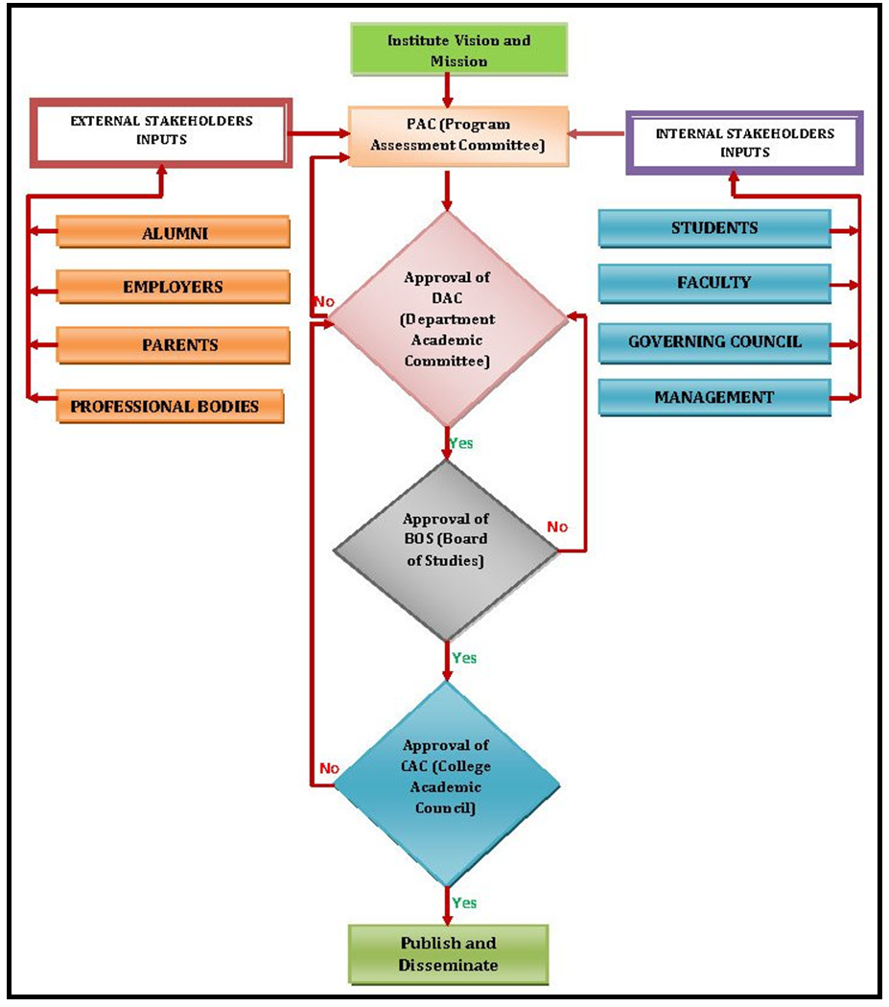

Fig.1.1.3.1 Process for Defining the Department Vision and Mission

